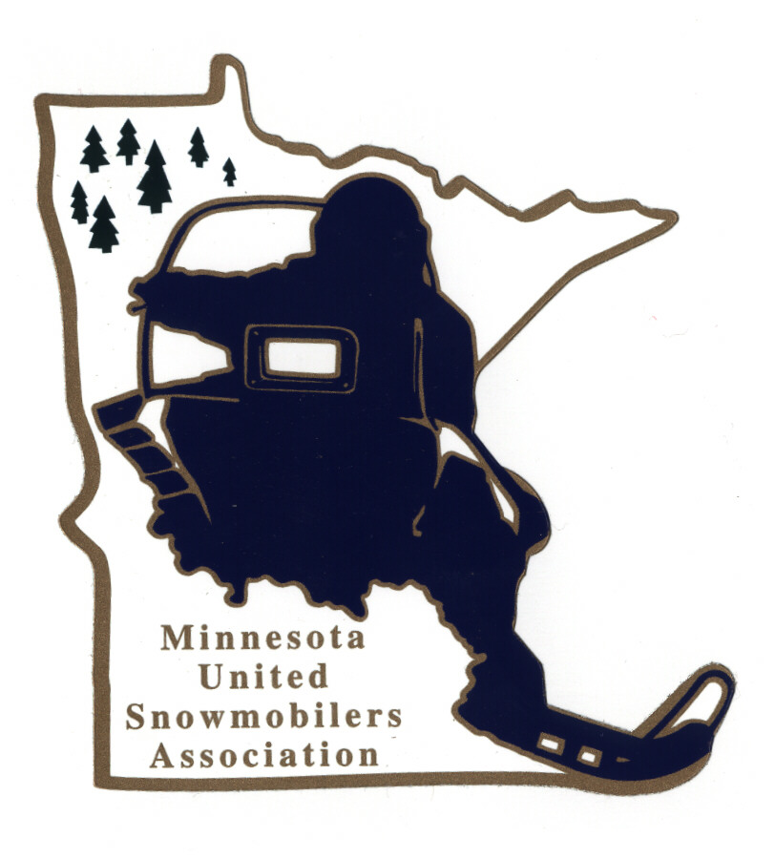
Minnesota United Snowmobilers Association

2025 Scholarship Program
14000 Sunfish Lake Blvd NW Ste. L – Ramsey, MN 55303
Office Email – office@mnusa.org
Charity/Awards Chairperson Janet Widness – jwstulk@prtel.com

MnUSA Charity & Awards Committee is proud to present 2025 Scholarship Program (up to $3,000) to graduating high school seniors pursuing education in an accredited 2-year or 4-year institution of higher learning or vocational school and/or individuals currently enrolled in such a program. Funds for the scholarship program are made possible due to the efforts of the MnUSA Fund Raising Committee and those who support our fund raising programs.

Applicant Requirements –
- Compose minimum 2-page Essay (doubled-spaced and typed) from following topic: With a greater responsibility for all riders to respect the generosity of landowners and stay on the trail.

“What would you do to educate and stop riders of all ages and experience
levels from trespassing and to stay on the trails?”

- Must be a good standing MnUSA member for past 3 years (if under 18 years or still in high school this will include membership as a son, daughter or legal ward of a family having current)
- Have passed the Minnesota Snowmobile Safety Course and have a Snowmobile Safety Certificate
- Complete application (preferred typed) with Student Activity Profile
- 2 Letters of Recommendation (relating your involvement with one about snowmobiling/club and one school/community)
- Include your name on all submitted pages
- Include a shoulder/head shot photo (can be your senior class photo)
- Submit to office and Committee Chairperson by mail or email no later than March 1, 2024

Judging and Qualifications –
- Committee judges all applications and verifies if qualify
- Judged based on 50% essay (content, ability to stay on topic, neatness, accurate spelling, correct grammar, etc.), involvement with snowmobiling/club (30%) and school/community (20%)
- Applicants may be interviewed
- All decisions of the committee are final
- Essay submission allows MnUSA to print in magazine and on website

Notification -
- Will be contacted by Chairperson if you have been accepted or not by mail or email
- Awarded Scholarship Certification will be in conjunction with applicant’s high school graduation or college/vocational school enrollment, and monies will be deposited with the school of the chosen enrollment to assist in offsetting the cost of continuing education.

Thank you for submitting your application.

MnUSA Office and Charity/Awards Use Only

Date of Arrival Circle - By: Mail or Email

Certifies that applicant is a good standing MnUSA member:

MnUSA Officer Name/Title Signature

----- Minnesota United Snowmobilers Association Scholarship Application 2025 -----

(can also type information in other program)

Name of Applicant Date of Birth

Address City State Zip

Phone: Home or Cell Email

Parent(s)/Guardian(s) Name(s)

Safety Certificate #/Date Completed / MnUSA #

School Info: Name (currently attending) GPA

Address City State Zip

Anticipated HS Graduation Date Plan Course To Study

School Planning To Attend Info: Name

Address City State Zip

Local Newspaper City of Newspaper

----- Applicant’s Student Activity Profile -----

Snowmobile Club Involvement Details: Club Name:

Club’s Activities Involvement:

Extra Curricular Activities/Years Participated/Leadership Positions:

Community Activities/Dates Participated/Hours Committee/Leadership Positions:

Awards Received/Year Presented:

Work Experience/Position/Dates:

