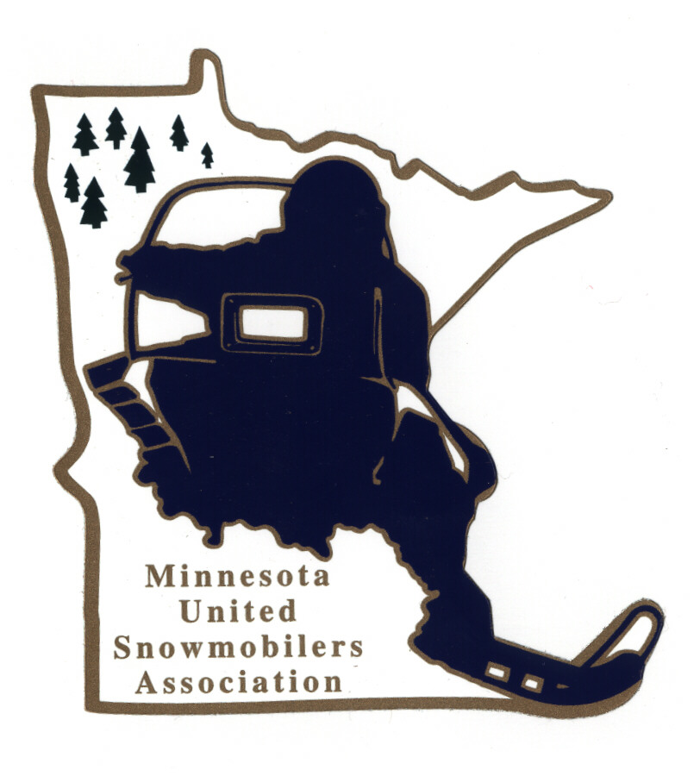
Minnesota United Snowmobilers Association

----- 2022 Snowmobile Family of the Year -----

7040 Lakeland Avenue North, Suite 212, Brooklyn Park, MN 55428
Office Email – mnusaoffice@popp.net
Charity/Awards Chairperson Janet Widness – jwstulk@prtel.com

MnUSA Charity & Awards Committee is proud to present 2022 Awards Program and will be presented at the 2023 Winter Rendezvous.

Nomination Requirements –
- Snowmobile Family who is deeply committed to organized snowmobiling and is involved with snowmobile organizations and strives to make the sport even more enjoyable in the future
- Must be a MnUSA member
- May be nominated by individual, snowmobile club/organization or by the nominee
- Must include responses to all topics addressed in this form (prefer typed)
- Include supporting documents, pictures, testimonials, etc.
- Must not have received this award within the last 10 years
- Submit to office and Committee Chairperson by mail or email no later than November 30, 2022

Judging and Notifications –
- Committee judges all applications and verifies if qualify
- All decisions of the committee are final
- Will be contacted by Chairperson if you have been accepted or not by mail or email

The winning MnUSA Snowmobile Family of the Year will also be submitted to American Council of Snowmobile Association (ACSA) National Award.

Thank you for submitting your nomination.

MnUSA Office and Charity/Awards Use Only

Date of Arrival Circle - By: Mail or Email

Certifies that applicant is a good standing MnUSA member:

MnUSA Officer Name/Title Signature

----- MnUSA Snowmobile Family of the Year 2022 -----

(can also type information in other program)

Snowmobiler Family Name: MnUSA #:

Address: City: State: Zip:

Phone – Home or Cell: Email:

Local Newspaper: City of Newspaper:

Nominated By Name:

Address: City: State: Zip:

Phone – Home or Cell: Email:

----- Snowmobile Family of the Year’s Profile -----

Snowmobile Family Is Active Member Of What Snowmobile Club(s):

How Many Years Been Active In Organized Snowmobiling?

Describe What Leadership Positions/Dates of Activity Each Family Member Holds and Has Held in a Club, Region, State and/or National Snowmobile Association:

Name and Explain How The Snowmobile Family Participates in Club and Association Fund Raising Events (the fund raising does not have to be restricted to snowmobiling):

Describe Does The Snowmobile Family Represent Snowmobiling and Snowmobilers at Club, Regional, State and National Activties:

Explain How The Snowmobile Family is involved in All Phases of Snowmobiling:

Describe How The Snowmobile Family Promotes Club Membership:

Describe Any Special Projects The Snowmobile Family Currently Participates In:

Give A Brief Summary About Your Nominee (200 words)

