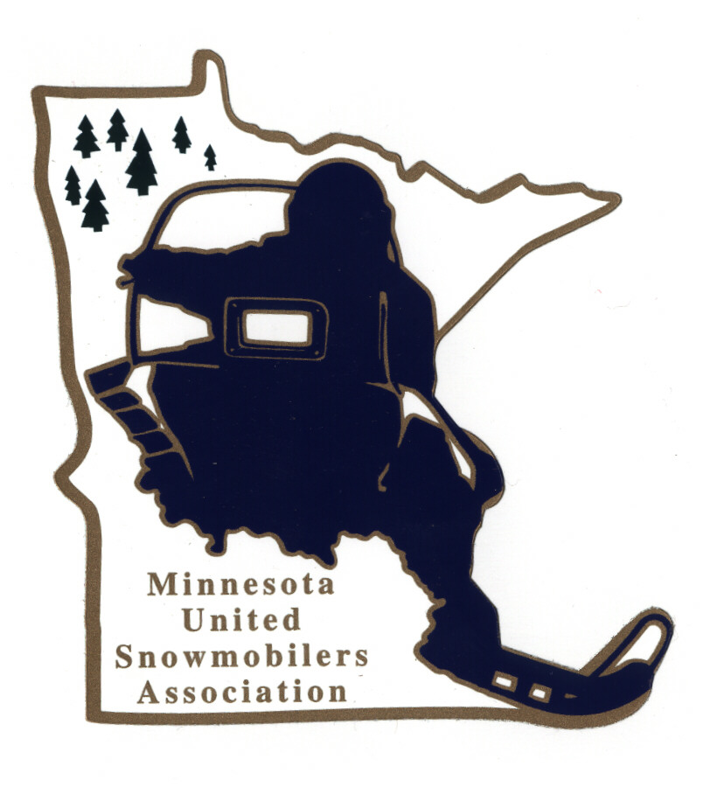
Minnesota United Snowmobilers Association

----- 2022 Unsung Hero Award -----

7040 Lakeland Avenue North, Suite 212, Brooklyn Park, MN 55428
Office Email – mnusaoffice@popp.net
Charity/Awards Chairperson Janet Widness – jwstulk@prtel.com

MnUSA Charity & Awards Committee is proud to present 2022 Awards Program and will be presented at the 2023 Winter Rendezvous. The future of our sports depends on the involvement of today’s youth. We have many young adults going the extra mile to help protect our sport.

Nomination Requirements –
- Nominees must be a MnUSA member (not on the MnUSA Executive Board or a Region Director)
- Must have gone beyond the call of duty to expose, promote, improve, preserve and main the sport of snowmobiling in the State of Minnesota, his/her region or community
- Include supporting documents, pictures, testimonials, etc.
- Must not have received this award within the last 10 years
- Submit to office and Committee Chairperson by mail or email no later than November 30, 2022

Judging and Notifications –
- Committee judges all applications and verifies if qualify
- All decisions of the committee are final
- Will be contacted by Chairperson if you have been accepted or not by mail or email

Thank you for submitting your nomination.

MnUSA Office and Charity/Awards Use Only

Date of Arrival Circle - By: Mail or Email

Certifies that applicant is a good standing MnUSA member:

MnUSA Officer Name/Title Signature

----- MnUSA Unsung Hero Award 2022 -----

(can also type information in other program)

Nominee’s Name: Years MnUSA Member

Address: City: State: Zip:

Phone – Home or Cell: Email:

Local Newspaper: City of Newspaper:

Nominated By Name:

Address: City: State: Zip:

Phone – Home or Cell: Email:

----- Unsung Hero of the Year’s Profile -----

Explain Why Your Nominee(s) Is/Are A Snowmobile “Hero” (up to 2 pages)

Give A Brief Summary About Your Nominee (200 words)

