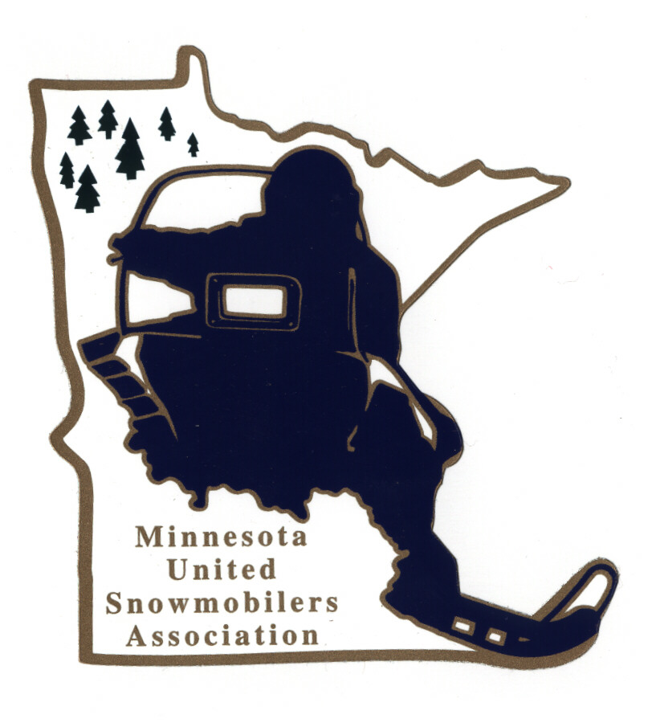
Minnesota United Snowmobilers Association

----- 2022 Club of the Year -----

7040 Lakeland Avenue North, Suite 212, Brooklyn Park, MN 55428
Office Email – mnusaoffice@popp.net
Charity/Awards Chairperson Janet Widness – jwstulk@prtel.com

MnUSA Charity & Awards Committee is proud to present 2022 Awards Program and will be presented at the 2023 Winter Rendezvous.

Nomination Requirements –
- A Snowmobile Club that is deeply committed to organized snowmobiling and is involved with snowmobile organizations and strives to make the sport enjoyable for its members and others.
- Must be a MnUSA member and/or business sponsor
- Must include responses to all topics addressed in this form (prefer typed)
- Include supporting documents, pictures, testimonials, etc.
- Must not have received this award within the last 10 years
- Submit to office and Committee Chairperson by mail or email no later than November 30, 2022

Judging and Notifications –
- Committee judges all applications and verifies if qualify
- All decisions of the committee are final
- Will be contacted by Chairperson if you have been accepted or not by mail or email

The winning MnUSA Club of the Year will also be submitted to American Council of Snowmobile Association (ACSA) National Award.

Thank you for submitting your nomination.

MnUSA Office and Charity/Awards Use Only

Date of Arrival Circle - By: Mail or Email

Certifies that applicant is a good standing MnUSA member:

MnUSA Officer Name/Title Signature

----- MnUSA Club of the Year 2022 -----

(can also type information in other program)

Club Name: MnUSA #:

Address: City: State: Zip:

Business Phone: Email:

Local Newspaper: City of Newspaper:

Nominated By Name:

Address: City: State: Zip:

Phone – Home or Cell: Email:

----- Club of the Year’s Profile -----

How Many Members Are Currently In The Club?

Has The Membership Increased Over The Past Year?

Does Your Club Have Young Members? If Yes, How Many?

How Many Years Has The Club Been Active?

Does Your Club Have A Website and Address

Does You Club Have A Facebook Page and Address

Describe How Your Club Promotes Membership To New People

Does Your Club Groom Trails? If yes, explain

Describe Any Local, Regional, State and National Government Meeting or Legislative Activities In Which The Club Has Been An Active Participant

Name and Explain How The Club Participates In Club and Association Fund Raising Events. The Fund Raising Does Not Have To Be Restricted To Snowmobiling

Does Your Club Have Any Partnerships With Other Organizations? If yes, explain

----- MnUSA Club of the Year’s Profile -----

Describe How The Club Represents Snowmobiling and Snowmobilers At Club, Regional, State and National Activities

Describe How The Club Promotes Safe and Responsible Riding For Members and Non-Members

Describe The Methods Your Club Uses To Introduce Non-Snowmobilers To The Sport

Outline Any Activity(s) The Club Has Done In The Past Year To Promoted A Positive Image Of Snowmobiling

What Are The Three Most Important Events Organized By Your Club In The Last Two Riding Seasons?

What Distinguishes This Club From Other Clubs?

What One Special Thing Should We Know About Your Club?

Give A Brief Summary About Your Nominee (200 words)

